****Accounting Guidance Notes:   
External Trading – non-primary purpose**

### Definition of Primary Purpose and Non Primary Purpose activity

The purpose of this guidance is to explain how external trading activity is identified and accounted for within the University. External trading activity is activity which does not meet the criteria to be treated as primary purpose activity, and is accounted for using activity 25 on Oracle.

A primary purpose ‘activity’ is one that furthers the charitable objects of the University. University Statute I, paragraph 3 provides:

*“The principal objects of the University are the advancement of learning by teaching and research and its dissemination by every means.”*

In addition to this, a charity’s primary purpose activities must also provide public benefit as defined by the Charity Commission. Therefore, in order for a University activity to be considered primary purpose, it must **both**:

* further the University’s charitable objects; and
* be for public benefit and any private benefit must be incidental.

The accounting treatment for the University must distinguish primary purpose activities from non- primary purpose. See Table A below and Appendices 1 and 2 to help with your decision as to whether an activity is primary purpose or non-primary purpose trading.

Income which does not meet the criteria for primary purpose falls outside the University’s exemption from corporation tax, and could lead to the University paying tax if not categorised correctly.

It is a major risk to the University that non-primary purpose trading is not distinguished from primary purpose activities. This potentially could result in tax liabilities and fines.

### How to account for Non-Primary Purpose activities

The University uses an activity code to account for general trading and other non-primary purpose activities. **Activity 25** is used as the flag to distinguish these transactions from others within Oracle Financials. Sales invoices input as “trading” will be automatically posted as Activity 25. However, trading / Activity 25 invoices look identical to other University invoices. So customers will be unaware of whether the invoice is raised as trading or non-trading. All non-primary purpose income, direct expenses and journals for non-primary purpose activities should be coded to Activity 25.

Table A provides examples of primary purpose and non-primary purpose activities.

**TABLE A**

| **Type of Activity** | **Description and examples** |
| --- | --- |
| Activities directly associated with students | These activities are the core activities of the University and regarded as **primary purpose.**  Examples:   * education; * teaching staff; and * teaching facilities. |
| Activities indirectly associated with students | These are also known as ‘Ancillary Services’. They are activities that wouldn't exist but for the students. They are services associated with teaching or research and provided to students and staff. Ancillary Services are **primary purpose** activities.  Examples:   * Conferences by visiting academics on educational topics * provision of services to students and staff on campus; * catering; * accommodation; * vending machines; * car parking in support of educational activities; * photocopying; * internet facilities; * provision of places at a crèche for children of our students in return for payment; and * income generated by the university as commission from service providers in delivering services to students. eg Use of cash machines. * managed car parking space provided to staff or students   The VAT treatment is different for services provided to staff and students. Please contact the VAT team to discuss VAT codes. |
| Conferences and courses  Conferences and courses (continued) | A ‘conference’ or ‘course’ is an organised meeting for a number of people for discussion, consultation and learning.  **They may be primary or non-primary purpose**.  Examples of **primary purpose** conferences and courses:   * conferences or courses run by the University where the focus is on education, research topics and the sharing of knowledge; * conferences or courses for students, researchers, post-graduates or University staff; * University academic conferences/courses; * a conference or course held for a third party organisation provided there is public benefit.  e.g. the course is open to the public and/or University staff/student; or the course participants are public sector eg programmes run by the Blavatnik School of Government.   A **non-primary purpose** conference or course is where one of the following applies:   * the attendees are drawn from a narrow range of the general public and the course is closed to others; * the criteria for selection for the course exclude the wider general public, i.e. no public benefit; * the benefit is not to a sufficiently wide sector of the public; and * the level of fees is set at a rate which excludes a substantial proportion of the public.   Examples of **non-primary purpose** conferences and courses:   * A conference or course designed or developed for a **private organisation**; A conference or course restricted to a narrow group of people **rather than to the wider public** where the conference/course participants are not primarily students, researchers, post graduates, university staff or public.   Please note that even where a conference or course is **primary-purpose**, if it is sponsored by a commercial entity, the sponsorship income may be **non-primary purpose**. This will be the case if there is advertising for the sponsor e.g. the conference is named after them, or their logo appears on the conference materials (other than as an acknowledgement of the sponsor’s contribution). |
| Consultancy Services | This is the offering of expert and professional advice on a commercial basis in order to generate income. Consultancy services are generally **non-primary purpose**. This includes consultancy services provided to other universities or other charities if undertaken on a commercial basis for a fee.  Services to other Universities – this can only be primary purpose if it furthers the University of Oxford’s own teaching or research. |
| Research | Research is the advancement of education or knowledge across a range of academic subjects.  It is helpful to try to distinguish between research activities which further the University’s charitable purposes and those which exploit research undertaken by the University. Charitable research must be conducted for the benefit of the public by the dissemination of useful knowledge acquired from the research to the public and others able to utilise or benefit from it.  Research will normally qualify as charitable only if:   * The subject matter of the proposes research is a useful subject of study * It is intended that the knowledge acquired as a result will be disseminated to others and * The research is conducted for the benefit of the public or a section of the public   Any private benefit (non-charitable) must be legitimately incidental to the achievement of the University’s aims for the public benefit.  **Provided the above test is met then the research will be primary purpose. For example, where the results of the research would be published in a reasonable time, then there is public benefit by the dissemination of the knowledge into the public domain.**  Research services for an NHS trust: research which advances the University’s charitable purposes for the public benefit would be primary purpose. If it is published we could argue it was primary purpose.  If there is no possibility to publish the results and they are for the sole use of the NHS trust, it would be non-primary purpose. Each contract must be considered separately. Research would be **non-primary purpose** where any results are owned by the sponsor, and the University is not expected to be able to disseminate them. |
| Testing services | Testing services provided to other entities will normally be non-primary purpose, where these do not further Oxford’s own teaching or research. This applies even where they support research being carried out by another University.  For example, the provision of carbon dating services to another University should be non-primary purpose trading. |
| Non-student lettings, rental income and hire of space | Standard property letting income can be treated as part of the University’s investment activities and there is a specific exemption for Corporation Tax purposes. **The rental income and incidental landlord services can be treated as exempt from Corporation tax.** This should be accounted for under **activity 00.**  Examples of income that can be treated as investment activity of the University includes:   * Rental income in relation to a part of a building leased to a tenant, including if the tenant is a private company * Rental income in relation to residential accommodation on a long-term basis, whether to students or not * Hire of a lecture theatre for a course or conference held by a separate entity, if no additional services are provided other than the space   This income does **not** need to go through Activity 25.  Examples of income that need to be treated as **non-investment income** include the below. This should be accounted for under A**ctivity 25**:   * Hire of University premises for a wedding or corporate event with catering or where help planning the event is provided * Hire of University premises for a language school run by a commercial operator with services such as catering * Rental of rooms on a short-term basis where other services are provided (similar to hotel accommodation) * Additional services provided to tenants e.g. IT support |
| Royalty income | Passive royalty income can be treated as **primary purpose** no matter who the customer is and the income is exempt from Corporation tax.  If, however, it is developed commercially to generate income then it would be routed through Activity 25.   If OUI developed a trademark or patent commercially then the income passed back to the University (assuming that the University owned the trademark/patent) then this would still be passive income in the University and not taxable. |
| Services delivered to support Colleges, Universities | Services to **other Universities** – this can only be primary purpose if it furthers our charitable purposes not theirs. If the University supplies services or testing to other Universities then this should be treated as non-primary purpose Activity 25.  The majority of services provided to Oxford colleges will be primary purpose, as the University and college collaborate closely on the teaching of students. This includes where the service is supporting the overall running of the college, and where it is supporting primary purpose teaching and research.  Where services to Oxford colleges are supporting commercial activities, these would be non-primary purpose (activity 25).  For example, the supply of staff to colleges by TSS is primary purpose when the overall running of the colleges (e.g. administration, finance). But where staff are being provided to support a commercial event such as a wedding then it would be non-primary purpose. |
| Cost sharing | The nature of the cost sharing income or expenditure will depend on the nature of the costs being shared. Please take advice from the tax team if you are thinking of share costs with other entities. |
| Staff secondment | **They will generally be non-primary purpose.**  Example of **non-primary purpose -** Staff Secondment:   * An employee of the University going to work for a commercial company for an amount of time then returning to his / her previous post at the university. e.g. a member of staff from Engineering Science going to work for Renault F1 Team.     Please take advice from the Tax team, if you are thinking of seconding a member of staff as there are VAT reliefs that could be used. |
| Publishing | The principle objects of the University are the advancement of learning by teaching and research and its dissemination by every means. University departments that publish books are of educational and academic material for these purposes. This activity is **primary purpose**.  Examples of ‘primary purpose’ publishing:   * Specialist material into new subject areas or building on specific prior publications; * Titles written by scholarly authors; * Learning and educational books. |
| Sale of inventory to an outside body or the general public | An outside body is anyone who operates outside the University. This is likely to be **non-primary purpose**, unless it is ancillary to the University’s teaching or research.  Examples of sale of inventory which would be **non-primary purpose**:   * Gift shop sales; * Sale of inventory to a commercial entity   Examples which would be **primary purpose:**   * Sales of course materials or stationery to students |
| Other sales of services to outside body or general public | Sales of other services to third parties on a commercial basis with a view to generating income are generally **non-primary purpose** (although certain services might be regarded as ancillary to the furtherance of the University’s primary purposes).,.  Examples of other sales or services which would be **non-primary purpose**:   * an outside body using a machine owned by the University, and then billed for 'machine time'; * technical analysis, sample testing, and data processing services; * ‘services rendered’ agreements provided by the University. |

**Accounting for costs for NPP activities**

Any costs which relate directly to non-primary purpose activities (direct costs) should be posted to activity 25. In addition, an apportionment of reasonable indirect costs to provide that activity must be made.

Table B below identifies the types of costs that may need to be allocated to non-primary purpose activities. For direct costs, the cost would be posted to activity 25 in full. All other relevant costs need to be apportioned between the non-primary purpose and primary purpose activities on one of the bases shown in Table B.

**TABLE B**

|  |  |
| --- | --- |
| **Type of cost** | **Description and example** |
| Direct costs | These are variable costs that relate wholly to the activity and which are priced according to volume.  Examples:   * The cost of buying goods for sale in a commercial gift shop. * A staff member’s salary while they are on secondment at a commercial company * Salaries of staff who only spend their time working in a commercial gift shop and do not carry out any other activities. |
| Indirect costs | Fixed costs that relate wholly or partly to the activity, and which will not change regardless of the level of sales.  Also organisational or administrative costs that support many separate activities, and which will not directly reflect the level of sales.  Examples:   * A charge for the use of a building. Part of the building is occupied by a commercial shop, part by research staff. * Running costs of a machine which is used both for research and for testing Rolls Royce components as part of a commercial contract with Rolls Royce. * Stationery, telephone, heat and light costs that are used by the department as a whole. * Salaries of receptionists, finance staff or other admin staff who support the running of the whole department. |

### How to identify Indirect Costs

Run the UO GL Transaction Listing by Period – Cost Centre – Account report ([www.admin.ox.ac.uk/finance/support/reportslibrary/standard/transactionlisting/](http://www.admin.ox.ac.uk/finance/support/reportslibrary/standard/transactionlisting/)).

Go through a list of all expense accounts and cost centres and flag those which have a bearing on the activity. Only costs that are relevant to the activity should be included, but this can include the costs of activity that supports the running of the department as a whole e.g. admin staff time.

Typical indirect costs include staff time, telecommunications, electricity, rent, cleaning, etc.

Only genuine costs which have been incurred by the department should be allocated to activity 25. This may include internal charges from other departments.

**Basis for Apportioning Indirect Overhead Costs**

There are a number of ways which indirect overheads can be apportioned – they can be multi-level and extremely complicated or straightforward and simple. At the University we advise that all indirect overheads be apportioned, in total, on one of the four methods below. There is no way of getting an ‘exact’ apportionment; what you are looking for is something that is reasonable in light of the overall usage.

**TABLE C**

|  |  |
| --- | --- |
| **Type of apportionment** | **Method** |
| Income based | Ratio of external trading income to total income. |
| Equipment usage | Ratio of NPP usage to total usage of equipment. |
| Periodic charge | Percentage of staff time used for non-primary purpose activities. |
| Floor space | Ratio of floor space used for NPP activities to total floor space. The Estate’s Directorate has floor space data on the Plan on database which can be used. |

**Note:** the key is that the basis used is reasonable. Please contact the Subsidiary Companies team if you require further assistance (externaltrade@admin.ox.ac.uk).

**Journals to Allocate Indirect Overhead Costs**

The same natural account and cost centre as the original transactions should be used where overheads are allocated to activity 25.

For example, to apportion £100k support staff costs on 50210 and £5,000 telecommunication expenses on 63110, the journal would be as follows:

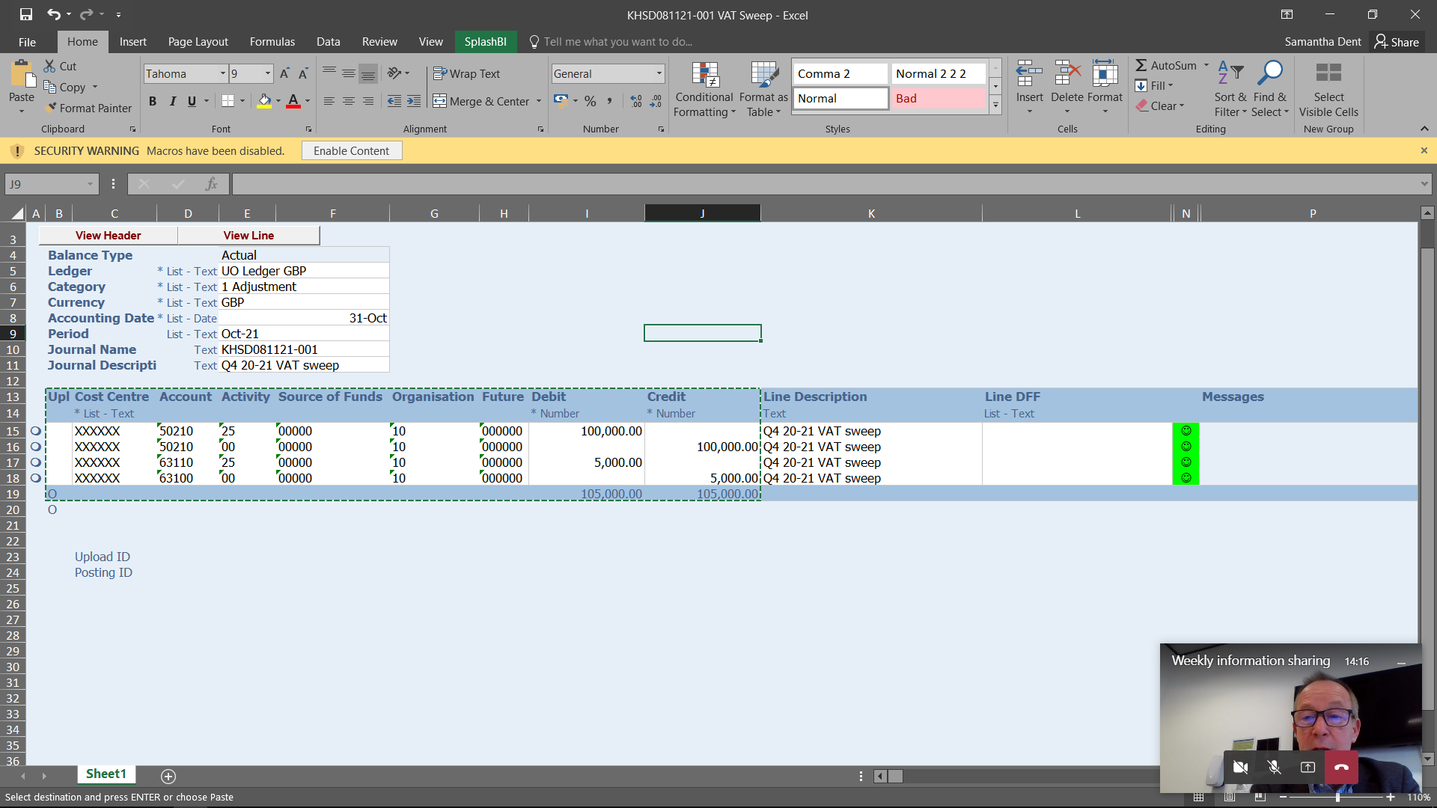

Some natural accounts can only be used with certain activity codes:

|  |  |
| --- | --- |
| **Natural Account** | **Activity Code** |
| 48210 Sales & Service | Can only be used with:  25 Trading External  33 Internal Trade  39 Subsidiaries |
| 48220 Consultation Fees |
| 99700 Cost of Goods Sold |

To journal primary purpose income that was incorrectly charged against the above Natural Accounts, you will need to amend the Natural Account code to 48300 Incidental sales – non-profit or 49320 Other misc income.

**Record Keeping**

It is crucial that support is kept on file for all costs posted to activity 25. In the event of an HMRC compliance check, these would need to be available, and would need to be in a form that could be easily understood by someone not familiar with the department.

Records need to include details of the calculation that was carried out and the source of all the inputs. It should be clear how the amount posted to activity 25 can be traced back to transactions on Oracle.

**Commercial Projects**

It is now possible to set up commercial projects on the projects ledger, for non-primary purpose work carried out by the department. This may be useful where a piece of work is expected to be carried out over a number of years.

The process to get these set up is the same as for departmental projects. Please email [dept.projects@admin.ox.ac.uk](mailto:dept.projects@admin.ox.ac.uk) for more information.

Income and direct costs allocated to commercial projects are posted to activity 25 by the team within the Finance Division.

Indirect costs will not appear on the projects ledger. These need to be apportioned to the project where relevant, and allocated to activity 25 via a journal. The process is the same as that described above.

**Appendix 1**

Use this decision tree to help determine whether your activity is trading.

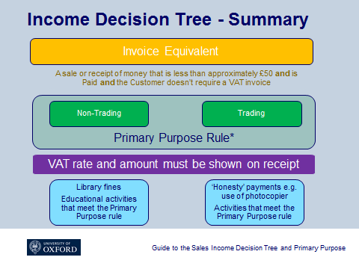

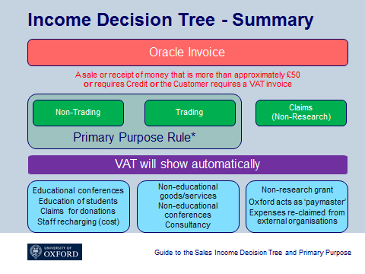

**Appendix 2**

If your activity is trading, then use this decision tree to determine whether it is primary or non-primary purpose trading.

